SOMERSET ARCHAEOLOGICAL AND NATURAL HISTORY SOCIETY cio
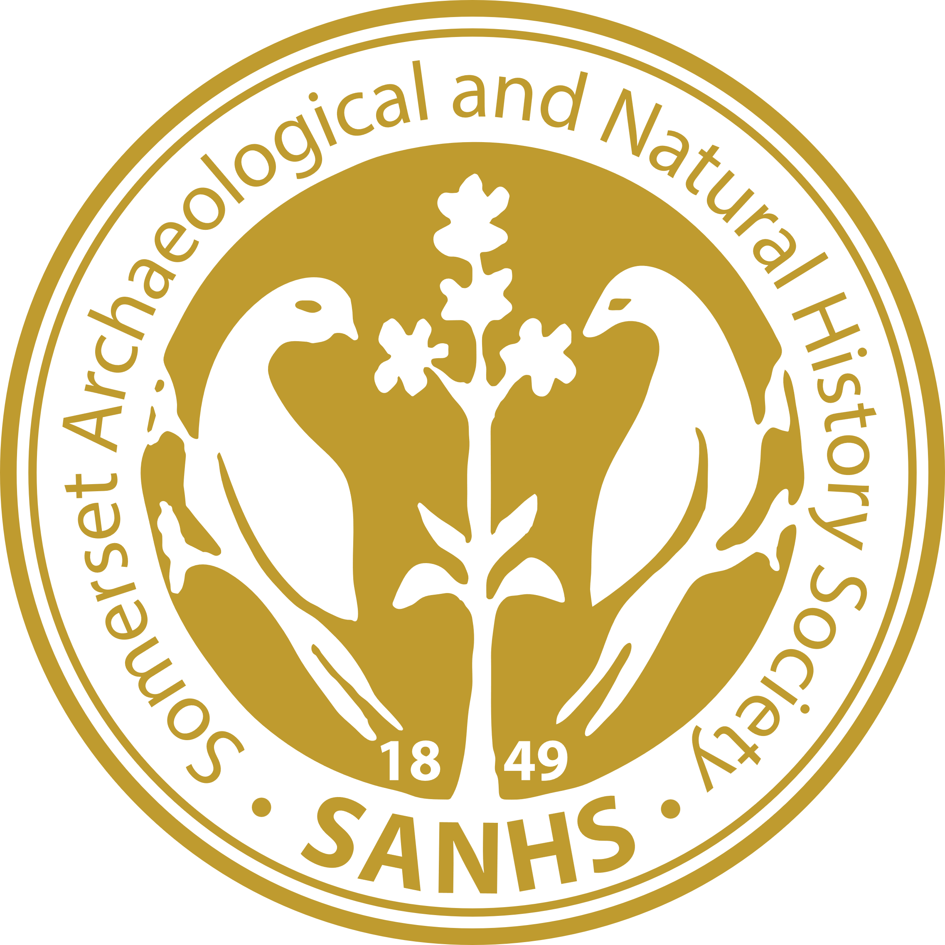

The Reconvened 2026 Annual General Meeting

17th October

To be held at Wyndham Hall, Castle Green, Taunton

Refreshments will be served at 10:00 for a 10:30 start.

AGENDA

1. |  | Welcome by the Chair
2. |  | Apologies for Absence
3. |  | Annual Accounts 2025 | Paper 1

Meeting business will be followed by a guided walk by Mary Siraut along the Mill Leat to the Coal Orchard.

We will be finished by lunchtime.

