SOMERSET COUNCIL

Annual Report by Somerset Council
to Somerset Archaeological and Natural History Society
1 April 2025 – 31 March 2026

Introduction

This report provides a summary of activity relating to the care and management of the SANHS museum collection from the 1 April 2025 to 31 March 2026.

During this year, the South West Heritage Trust developed a new five-year strategy covering 2025–2030. This focuses on three priority areas: People and Communities, Protecting our Heritage and Building a Thriving Trust. These align closely with the priorities of principal local authority funders and sector bodies.

Funding for Trust services continues to come from core grants from Somerset Council and Devon County Council, alongside contracts, commercial activity and grant income. Additional investment has been secured from organisations including Arts Council England, Taunton Town Council and Bridgwater Town Council. Despite ongoing financial pressures, effective management of savings plans and income generation has helped maintain financial stability. The Trust remains deeply appreciative of its partners and, in particular, the continued support of Somerset Council and Devon County Council.

The Trust’s culture is centred on working collaboratively as a single organisation delivering a wide range of heritage services. This work is made possible through the commitment of staff and volunteers, alongside the Somerset Archaeological and Natural History Society and Friends organisations, supporters, partners and all those who actively champion the Trust’s work.

The relationship between the Society, the Council and the Trust has continued to be expressed through a pattern of regular meetings and not least through the SANHS Museum Collections Panel. Where actions, events or activities referred to in this report have involved SANHS assets or co-operation, that involvement is here very gratefully acknowledged. In respect of the museum collections, those belonging to the Society, the Council and others are distinct in ownership and documentation but are curated and interpreted by the Trust as a single resource because of their complex curatorial inter-relationship. The Forward Plan accompanying this Annual Report indicates actions, events or activities that include collections belonging to the Society.

1. Workforce

During 2025–26, the South West Heritage Trust’s Somerset workforce experienced a period of consolidation and targeted growth. Staffing changes reflected planned departures alongside investment in skills and capacity to support major delivery priorities, including the Chew Valley Hoard Project, expanded learning and engagement activity and organisational transformation. The focus throughout the year has remained on staff wellbeing, succession planning and professional development.

1.1. Staff Changes and Departures

Staff turnover occurred across several services. Notable retirements included Simon Almy (Caretaker at the Somerset Rural Life Museum), who retired in May 2025 after 27 years of service, and Sandy Thomas (Learning Officer at the Somerset Rural Life Museum), who also left the Trust in May 2025 following a long-standing contribution to heritage learning.

Other departures included Judeth Saunders (Assistant Curator) at the end of a fixed-term contract and Brontë Fry (Assistant Conservation Officer), who left to join Somerset Council. Later in the year, Victoria Haddock (Exhibitions and Programmes Assistant), Amelie Clegg (Trainee), Alex Fergie (Digital Marketing Assistant) and Harriet Moffatt (Archives and Local Studies Researcher) also left the Trust following contract completion or to pursue further study or new roles.

1.2. New Appointments and Internal Progression

New appointments and internal progressions strengthened capacity across Somerset services. Nicholas Cohen White was appointed Senior Learning Officer (Schools and Early Years). Natasha Giles continued to support the Learning Service as a freelance Learning Delivery Officer and, following an internal recruitment process, as a Visitor Services Assistant at the Somerset Rural Life Museum. The appointment of Melanie Coussens as Exhibitions and Programmes Manager in June 2025 strengthened leadership of the exhibitions and public programme.

In the Archives and Local Studies team, Emilia Silaste progressed into a permanent role as Somerset Archives and Local Studies Researcher and Harry Morris joined as Customer Service Assistant at the Somerset Heritage Centre. In the Museums team, Mary Creed moved into a full-time permanent role at the Somerset Rural Life Museum and Angela Willis was recruited as Engagement Officer for the South Somerset Heritage Collection, supporting future engagement planning with Yeovil Town Council and local partners.

1.3. Skills Development, Early Careers and Apprenticeships

Professional development has remained a priority. Twelve members of staff completed a Leadership and Management Development Programme delivered by Mandy Simms, who also facilitated leadership and Trust-wide business planning workshops. Staff also accessed specialist training through national and regional programmes.

Early career development continued through apprenticeships and placements. Phoebe Croucher (Multi Channel Marketing Apprentice) contributed extensively to digital marketing, exhibitions and National Portfolio Organisation (NPO) activity while completing her qualification with Bridgwater and Taunton College. Rae Pearson (previously an Apprentice with the Trust and now NPO Project Assistant) received a Highly Commended award in the Advanced Apprentice of the Year category, with the Trust also nominated as ‘Small Apprentice Employer of the Year’.

1.4. Project Roles and Volunteers

Specialist and time-limited posts have supported the delivery of major Somerset projects, including the Chew Valley Hoard Project, learning delivery and historic environment work.
Volunteers continued to make a vital contribution across museums, archives, learning and landscape sites. Volunteers supported front of house activity, collections work, learning sessions and creative delivery at Avalon Archaeology, including construction of the Iron Age Roundhouse. Their contribution remained integral to delivering high quality public services and caring for Somerset’s heritage.

2. Financial Sustainability

The past year has been shaped by impactful delivery, change and growing ambition across the Trust’s Somerset services. Following the successful securing of major capital and programme funding in 2024–25, activity in 2025–26 has focused on implementation, organisational resilience and public impact.

The most significant milestone was the formal start of the Chew Valley Hoard Project, following the award of nearly one million pounds from The National Lottery Heritage Fund (NLHF). A Project Delivery Group was established and an expert consultant team appointed, allowing work to begin on an ambitious programme of exhibitions, learning, community engagement and capital investment at the Museum of Somerset.

The year also maintained a strong focus on financial sustainability and commercial transformation. Following funding from the Arts Council England / Department of Culture Media and Sport’s Museum Renewal programme, reviews of retail, catering, ticketing and audience data informed new charging models for selected exhibitions, pilots for pricing strategies and the development of a Trust-wide programming framework aligned to audience insight and commercial objectives.

Across Somerset sites, public engagement remained strong, with record attendance at the Museum of Somerset in February half-term, growth in structured learning and outreach activity, and expanded participation by neurodiverse, rural and socially isolated audiences.

3. Audiences

Staff across the Trust have developed innovative ways of reaching audiences through community projects and partnerships.

3.1. Learning

The Trust’s Learning Service delivered another successful year, engaging children and young people across Somerset through onsite workshops, outreach, Early Years provision and hospital-based activity.

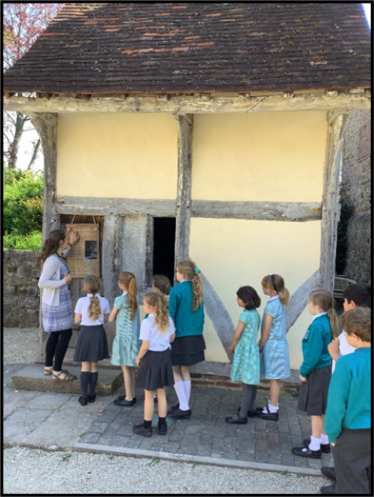
St Peter’s Primary School visit the Museum of Somerset

Across the academic year, more than 13,000 pupils participated in Trust-led learning with 493 school learning sessions being delivered. Outreach showed the strongest growth, reflecting continued demand from schools and the impact of a fully staffed outreach team. Museum-based workshops at the Museum of Somerset, Somerset Rural Life Museum and Somerset Brick and Tile Museum remained well attended.

The subscription programme for schools was fully subscribed for 2025–26, with many schools booking all their sessions in advance. Travel bursaries and targeted support continued to widen access for high pupil premium schools.

Significant work was undertaken to review the Formal Learning Service. An external review assessed the business model, educational relevance and long-term sustainability, with recommendations now being implemented through a phased action plan.

Health and wellbeing have remained an important strand. In partnership with NHS Somerset, creative sessions were delivered in children’s hospital wards at Musgrove Park Hospital and Yeovil Hospital. Arts Award linked activity supported confidence and achievement. Early Years provision at both major museum sites continued to develop, with refreshed sessions linked more closely to collections and place.

3.2. National Portfolio Organisation Programme

The Trust’s status as a National Portfolio Organisation (NPO), funded by Arts Council England, continued to drive audience development, inclusion and experimentation during 2025–26. Delivery of ‘The Stories That Make Us’ programme progressed through its third year, with sustained activity across all five strands of the Activity Plan alongside continued embedding of the Arts Council England Investment Principles.

The programme engaged early years audiences, young people, underserved groups, socially isolated adults and communities across Somerset. It also strengthened organisational capability through skills development, evaluation and data-led planning, ensuring learning from the last year informs future delivery.

The Early Years play-based sessions programme expanded in both scale and depth during 2025–26, reinforcing the Trust’s role in delivering high quality, heritage based early learning.

Delivery took place in nursery and childminding settings, libraries and museum sites across South Somerset, Sedgemoor, Taunton and rural West Somerset, engaging young children through creative play, sensory exploration and storytelling inspired by collections and place.

A key development was the piloting and refinement of sensory discovery resource packs at the Museum of Somerset and Somerset Rural Life Museum. These were trialled with families attending Toddler Explorer and Toddler Storytime sessions, with feedback informing final designs ahead of full rollout.

At Somerset Rural Life Museum, an artist-led pilot programme enabled deeper engagement with a local nursery and infant schools. Over four weeks, pre-school children and two Reception classes worked with four artists, exploring dance, song, poetry, visual arts and storytelling linked to the site and displays. Learning from the pilot will directly inform future Early Years practice.

Planning is now underway for a formal evaluation of the Early Years programme in 2026–27, covering both NPO activity and the Trust’s wider Early Years offer.

The Trust continued its partnership with Bridgwater and Taunton College through its hosting of Apprenticeships, with the Multi-Channel Marketing Apprentice playing a central role in NPO delivery.

Across the year, the apprentice supported digital marketing campaigns, website content, blogs, exhibition promotion and social media, including development of a digital exhibition linked to ‘A Life Outside: Hope Bourne on Exmoor’, marketing for major exhibitions and holiday programmes, and support for community engagement events.

The role also contributed to Collections to Communities and Social Prescribing activity through outreach events, pop-up museums and play days, supporting the promotion of Trust sites and programmes. The apprenticeship continued to combine practical delivery with structured learning and assessment, strengthening both skills development and organisational capacity.

The Social Prescribing strand continued to engage underserved and socially isolated adults, families and young people, with delivery informed by ongoing evaluation and learning.
Activity across Taunton and Mendip included reminiscence sessions, Memory Cafés, community ticket distribution and outreach delivered in partnership with organisations such as Green Days Adult Learning, Wellsprings services, care homes, community cafés, foodbanks and refugee support groups.

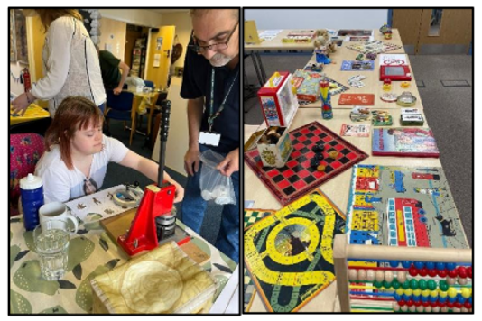
Participants from Green Days Adult Day Care
and heritage objects at the Somerset Heritage Centre

During the year, focus shifted towards prioritising the most effective formats of delivery, particularly Memory Cafés and partnership-led sessions, while refining or retiring less impactful approaches. Community tickets continued to widen access to museum programmes and seasonal events.

A three-year external evaluation of the programme by the University of Exeter was completed. Findings highlighted strong impact in Taunton, increased cultural confidence and wellbeing among participants, and the value of flexible, relationship-led delivery. The evaluation also identified the need for strategic adjustment in Mendip and strengthened qualitative data capture.

Learning from the evaluation is now shaping forward planning, including development of a funding bid to extend arts in health activity with young people in hospital settings.

Collections to Communities activity remained one of the programme’s most visible and wide-reaching strands, bringing heritage directly into community spaces across Somerset.
During the year, the Trust delivered pop-up museums, play days, festivals and ‘Together’ events, engaging families, young people and adults through hands on interaction with heritage objects, creative activities and storytelling.

Key highlights included:
- A pop-up museum in Bridgwater, developed with SEED Sedgemoor, attracting around 500 visitors.
- Participation in Somerset Day celebrations, reaching more than 1,000 people.
- Delivery at Glastonbury Festival, where a solar-powered photographic studio engaged over 1,000 participants.
- Collaboration with Yeovil and Bridgwater partners for play days engaging over 2,300 people during February half term.

Throughout the year, activity increasingly aligned with future strategic priorities, including early planning for community engagement linked to the Chew Valley Hoard and the development of a touring version of the Hope Bourne exhibition to reach West Somerset communities in 2026.

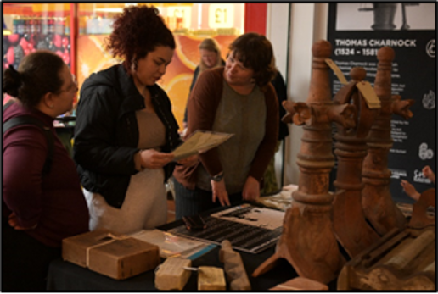
Pop-up Museum in Angel Place, Bridgwater

Digital and hybrid delivery continued to support participation, representation and access, most notably through the co-created exhibition Stories of Home at Weston Museum.
Working with community partners in Weston-super-Mare, the NPO team facilitated digital photography and audio workshops, engaging participants in sharing reflections on home, belonging and place. The exhibition opened in December and continued into 2026, attracting many first-time museum visitors.

Relationships developed through the project are now extending into healthcare settings, with plans to display digital portraits at Weston General Hospital and support wider arts and health initiatives.

Development continued on ‘Finding My Place’, a participatory digital project with young people currently in or leaving care. Guided by partner organisations and the young people themselves, the project is progressing at an appropriate pace due to its sensitive nature.

A programme of hybrid talks also continued, enabling both in person and online participation for rural and urban audiences.

Progress continued across all four Investment Principles throughout the year:
- Environmental Responsibility: Completion of the Natural History Collections review and continued reduction in carbon impact informed future environmentally focused programming.
- Dynamism: Data dashboards, programming matrices and a new digital strategy improved insight-led planning.
- Ambition and Quality: Independent evaluation of the Social Prescribing strand and planning for the Early Years evaluation embedded reflective practice.
- Inclusivity and Relevance: Equalities planning, trauma aware training and stronger links with care-experienced young people strengthened delivery.

4. The Museum of Somerset

The Museums Service has delivered a year of strong visitor engagement, programme development and organisational change across Somerset sites.

The Museum of Somerset received 74,907 visitors in 2025-6. The Museum of Somerset experienced particularly strong attendance during school holidays, recording its busiest day on record during February half term. A refreshed programme of family events, early years activity and seasonal programming supported continued audience growth. These included popular school holiday activities around the Ice Age and dinosaurs. Work also began to address decline in non-event footfall through targeted marketing, programme review and digital promotion.

4.1. Temporary Exhibitions

The 2025–26 exhibition programme combined national partnerships with local relevance and inclusive engagement.

After Sedgemoor: Remembering the Monmouth Rebellion (29 March – 6 July 2025)

After Sedgemoor marked the 340th anniversary of the Monmouth Rebellion in 1685. The
exhibition explored the rebellion’s tragic consequences and how they have been remembered by later generations. At the centre of the exhibition were two nationally important paintings, kindly loaned by the Tate and Manchester Art Gallery. The Morning of Sedgemoor by Edgar Bundy shows frightened rebels sheltering in a barn after the Battle of Sedgemoor and was on loan from the Tate. The Duke of Monmouth’s Interview with James II by John Pettie captures the scene as Monmouth pleaded with the king to spare his life and was on loan from Manchester Art Gallery.

The exhibition is part of the Trust’s celebrations to mark 150 years since the purchase of Taunton Castle by Somerset Archaeological and Natural History Society. The exhibition was opened by the Mayor of Taunton, Councillor Vanessa Garside, on Friday 28 March 2025. There were over 60 attendees including representatives of Somerset Council, Taunton Town
Council, Arts Council England and Somerset Archaeological and Natural History Society. The ‘After Sedgemoor’ exhibition was featured in The Guardian and on the BBC website.

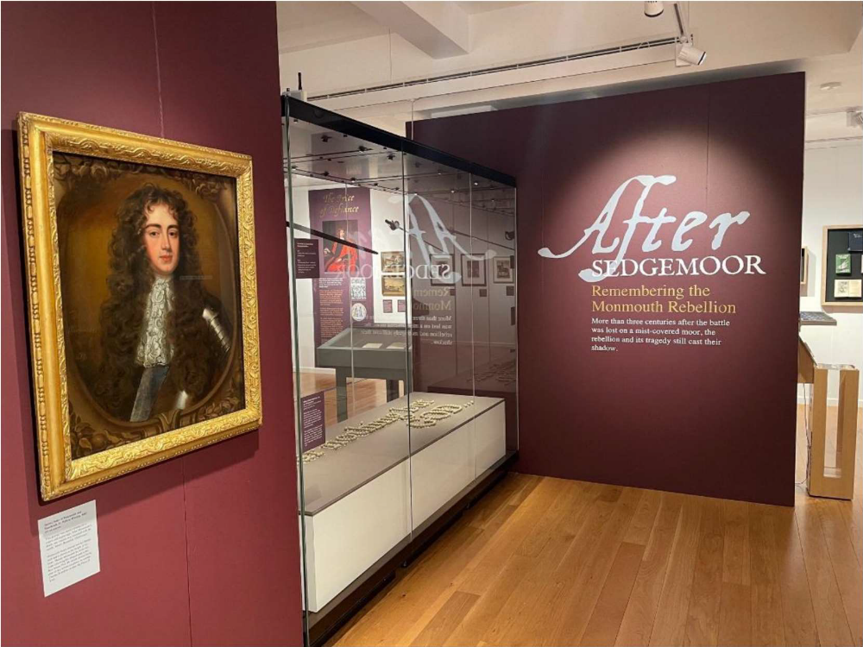
After Sedgemoor: Remembering the Monmouth Rebellion exhibition

Wow! Amazing Science in Children’s Books (22 July – 1 November 2025)

A family-focused exhibition created with ‘Events of Wonder’, the founders of the Bath Festival of Children’s Literature. This exhibition brought together vibrant artworks and surprising facts to inspire visitors to investigate the wonders of the world around us. The exhibition featured the work of some of the UK’s most well-known children’s book illustrators, including Oliver Jeffers, David Macauley, Marcia Williams and Yuval Zommer.

In addition to the 85 artworks on display, the exhibition featured an interactive digital
game, hands-on puzzle, and comfortable book area where families could relax and look
through the books that the featured illustrations came from.

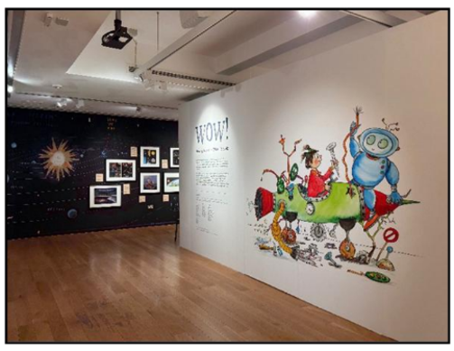
Wow! Amazing Science in Children’s Books exhibition,
Museum of Somerset

Beauty in Plainness: William Scott in Somerset: (17 November 2025 – 7 February 2026)

William Scott was a pioneering abstract painter, best known for his distinctive still life
and landscape compositions. After settling in Somerset in the 1940s, he taught at the
Bath Academy of Art for ten years and became a key figure in the post-war British art scene. In the 1950s, Scott developed a close friendship with American artist Mark
Rothko, who visited and stayed with him in Somerset in 1959.

This exhibition formed part of the Trust’s Spotlight Loan programme and featured three
largescale works from this pivotal period in Scott’s career, on loan from Tate, offering a
rare chance to experience bold, expressive art up close. An animated film further
explored the artist’s vision and life in Somerset.

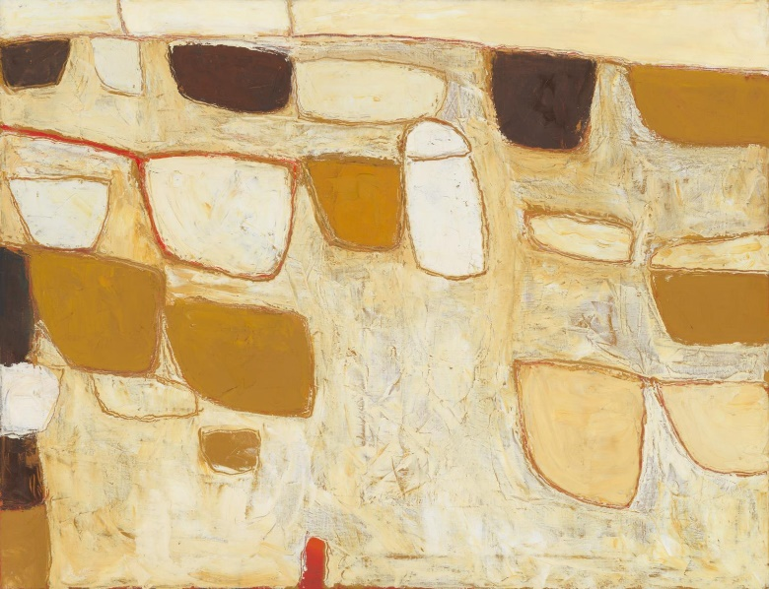
Ochre Still Life, 1958, by William Scott (1913–1989)

Roger Fry: A Life in Art (28 March – 4 July 2026)

A major exhibition focused on the Bloomsbury artist and critic, developed in collaboration with Charleston, Sussex. As part of the Bloomsbury Group, Roger Fry (1866-1934) helped spark new ideas in art, design and culture – inspiring a fresh, modern way of looking at the world. This exhibition included vibrant portraits, landscapes and interiors, including rarely seen works from private collections alongside important national pieces.

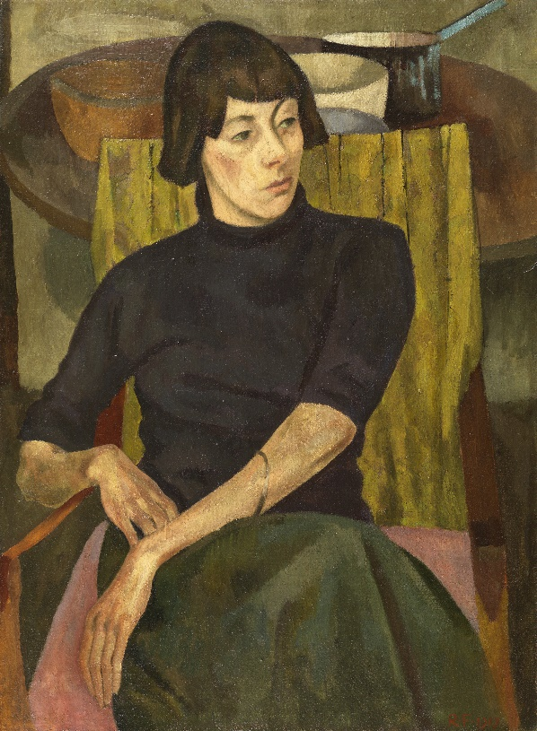
Portrait of Nina Hamnett by Roger Fry

4.2. Events and Activities

The regular programme of talks, workshops, and family activities has continued
throughout this period, with strong engagement in the Trust’s early years programme at
the Museum of Somerset. During February half-term, family audiences explored the
Rachel Reckitt exhibition at the Museum of Somerset.

On 27 September 2025, the Museum of Somerset supported Taunton Town Council’s
‘Taunton Together’ event, themed around the River Tone. The Museum provided a
starting point for the Goodlands Folk Tours, a venue for performances and print making
activities delivered by the Trust’s National Portfolio Organisation team.

A programme of thematically linked science crafts, activities and interactive shows
was delivered at the Museum of Somerset through the school summer holiday period
engaging participants with the Wow! exhibition. 10,000 visitors engaged with the
Museum over the school holiday period.

The outdoor theatre company The Three Inch Fools performed their Tudor musical The
Most Perilous Comedie of Elizabeth at the Museum of Somerset on 3 September 2025.

The 150th anniversary programme at the Museum of Somerset ran through to the end
of October 2025. Highlights included Tom Mayberry’s talk ‘The Arc of History’, which
drew 92 attendees. The programme concluded with family-orientated birthday-themed
activities during October half-term.

The Trust continued its second year of partnership with the Taunton Brewhouse Theatre
and University College Somerset. A group of Foundation Year Art and Design students
visited the Museum of Somerset for a guided tour and workshops with the Senior
Learning Officer, Senior Curator, Museum Manager and Assistant Museum Manager.
Inspired by their visit the students developed artworks for an exhibition at the Taunton
Brewhouse Theatre in January 2027.

4.3. Castle House

The holiday apartment continues to be let successfully and the ground floor has been used by a variety of local groups for meetings and workshops.

5. Somerset Rural Life Museum

The Somerset Rural Life Museum has seen a record number of visitors, with 31,208 attending in 2025–6. Visitor engagement remained stable, supported by exhibitions and family activity including the ever-popular animal-themed days. New collection additions, including the ‘Glastonbury Egg Van’, created new interpretive opportunities.

5.1. Temporary Exhibitions

The temporary exhibitions programme has showcased the varied work of local, regional and national artists.

Tractored by Beetles (21 June – 14 September 2025)

A group exhibition featuring six artists: Alice Crane, Jon England, Liz Gregory, Fiona Hingston, Tim Martin, and André Wallace. The exhibition took its title from the poem Fugitives by the Poet Laureate Simon Armitage celebrating the National Landscapes of the UK. The artworks, which ranged from sculpture to painting to textiles, printmaking and photography, encouraged fresh connections between the landscape, rurality and creativity.

A Life Outside: Hope Bourne on Exmoor (27 September 2025 – 10 January 2026)

Delivered in partnership with the Exmoor Society, this exhibition presented artworks and objects from the Exmoor Society archives and drew on new research by writer and Guardian Country Diarist Sara Hudston, whose book A Life Outside: Hope Bourne on Exmoor will be published in September 2026 by the Exmoor Society. The exhibition was co-curated by Kate Best and Sara Hudston for the South West Heritage Trust.

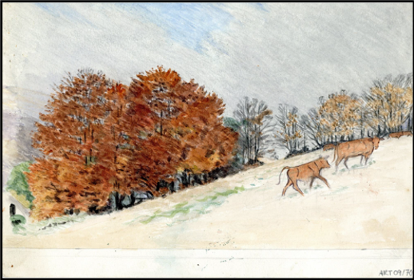
Illustration by Hope Bourne, Exmoor Archive

Legacy in the Making – Somerset Craft Guild: Past, Present and Future (24 January – 10 May 2026)

Created in collaboration with Somerset Art Works and the Somerset Craft Guild, this exhibition celebrated the legacy and future of the Somerset Craft Guild by showcasing the remarkable breadth of contemporary and historic craft in Somerset. Bringing together former members and masters of the Somerset Craft Guild, along with the 2025 Somerset Art Works x Somerset Craft Guild Emerging Maker Bursary artists, the exhibition reveals a vibrant creative community shaped by heritage, experimentation and deep connection to place.

6. Weston Museum

The Trust continued to provide curatorial advice and support to Weston Museum. Exhibitions have been a prominent area of activity in the last year.

6.1. Temporary Exhibitions

Designing Terry Pratchett’s Discworld – 30 Years of Paul Kidby’s illustrations (24 May 2025 – 30 August 2025)

An exhibition celebrating the collaboration between Paul Kidby and author Sir Terry Pratchett. A touring exhibition from St Barbe Museum and Art Gallery. This unique exhibition drew together a stunning selection of Paul Kidby’s paintings and drawings of Discworld characters.

A Decade Since Dismaland (13 September – 22 November 2025)

A major photographic exhibition celebrating Banksy’s Dismaland project at the Tropicana, Weston-super-Mare, in 2015.

Stories of Home (6 December 2025 – 14 March 2026)

A co-created exhibition focused on Weston as a home, featuring testimony and photographs of Weston people. This exhibition celebrated the communities of Weston and explored what ‘home’ and Weston meant to them. It featured photographic self-portraiture along with written and recorded stories of home and about the experience of living in Weston. A short film showcasing a number of personal stories about making a home in the town and life in Weston was created in collaboration with creative media organisation Somerset Film.

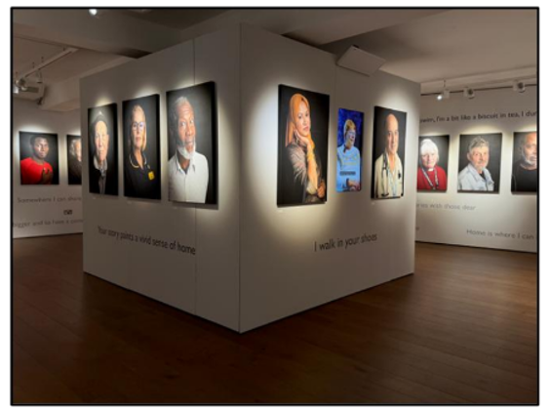
‘Stories of Home’ exhibition, Weston Museum

7. Somerset Brick and Tile Museum

The Somerset Brick and Tile Museum maintained strong engagement through partnership activity, SEND provision and community led projects, including delivery of activity for the Bridgwater Heritage and Art Trail. Work to achieve museum accreditation continues.

8. Avalon Archaeology

Avalon Archaeology continued to develop as a functioning heritage destination. The formal opening of the reconstructed Iron Age Roundhouse marked a major achievement for the site’s team of committed volunteers. Public events, workshops and home education sessions were consistently well-attended, with site opening extended during school holidays.

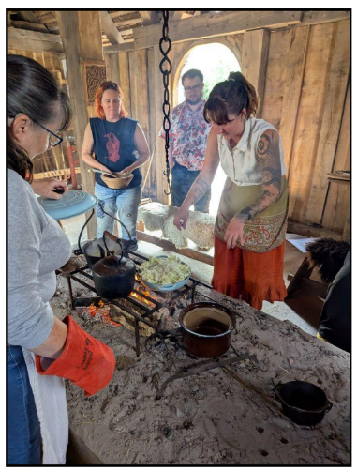
Cooking Workshop, Avalon Archaeology

9. Museum Development

Rachel Bellamy, Museum Development Officer (MDO) for Somerset, has continued to provide support to museums and heritage sites across the Somerset and North Somerset by working with colleagues at Museum Development South West (MDSW) to enable the county’s 63 museums to access grants, training programmes and other opportunities.

In 2025-6, the MDO supported 17 of the 18 priority museums within Somerset and North Somerset. Priority museums are non-national accredited museums that are not National Portfolio Organisations. The MDO also supported ten non-priority museums: Alfred Gillett Trust (Shoemakers Museum), Castle Cary Museum, Dovery Manor Museum, Gates Museum in Street, Ilchester Museum, Glastonbury Tribunal, Milverton District Archives, Minehead Museum, Watchet Boat Museum, Wellington Museum and Wincanton Museum.

A key part of the MDO’s role is to support museums to work towards achieving and retaining Arts Council England Accreditation status. In 2025-6 the MDO supported Watchet Market House Museum’s successful submission of their accreditation return in February 2025 with full accreditation status awarded in March 2025. The MDO also supported the Gauge Museum at Bishops Lydeard on their application for Accreditation, which was submitted in August 2025, with an award of full accreditation being made in December 2025. The MDO supported Blake Museum, Frome Museum and Wells and Mendip Museum as they prepared for their returns in 2025-6 and has also given preliminary advice to Glastonbury Abbey and Weston Museum ahead of invitations to submit a return.

Six museums were supported in their successful application for funding from the following MDSW grant programmes: Capacity Builder, On Display and Small Open Grants. The MDO has also supported seven museums with actions to support their organisational health.

Administrative support has been provided for the Museums in Somerset network. This has included the delivery of three county group meetings and the administration of the county Visit Somerset membership and Harwell subscription. The MDO has signposted museums to the MDSW Travelling Together and Growing Together programmes, the MDSW training programme and to advice and support from the MDSW specialist officers on volunteering and conservation. The MDO has also supported the development of partnerships within Somerset and the wider region.

10. Portable Antiquities Scheme

The Portable Antiquities Scheme team have continued their ongoing work to record archaeological finds in Somerset, Devon and Dorset in partnership with the British Museum. This year the team has also expanded its remit to temporarily cover Cornwall until a more permanent solution can be found for this county. The team has delivered over 37 finds surgeries and other outreach events at South West Heritage Trust sites and regional museums across the four counties, engaging with a range of audiences.

11. Collections

11.1. Accreditation

Staff delivered actions included in the Accreditation Forward Plan. Work has continued on revising this plan to cover the years 2026-9.

11.2. Reorganisation of the Museum Stores and Location Audit

Work has continued on the project to reorganise the museum stores and to update the storage locations of museum objects.

11.3. Collections Management System

We have continued to add to, check and upgrade data on the museum collections management system.

11.4. Conservation

Seonaid Wood (oil painting conservator) and Teresa Llewellyn (frame conservator) had completed the conservation work on the painting of Hannah Ellis in the previous year. The painting and frame have been collected and the painting has now been glazed and reframed by the Trust’s technical team, who have previously received training from Seonaid Wood.

The Curatorial Team purchased purpose-built racking to house the collection of friendly society banners. This cost just under £1,500, which the SANHS Museum Collections Panel kindly agreed to support through the Museum Collections Fund. The racking has now been assembled in Store F and the banners are gradually being transferred onto it.

Six of the friendly society banners are from the SANHS museum collection, including those from Blagdon Hill and Stratton-on-Fosse. This project follows on from the 2019 project to repack the banners in line with best practice and will ensure that the benefits of the earlier project are sustained.

11.5. Somerset Rare Plants Group

Work is progressing well on the Somerset Herbarium project. Six members of the Somerset Rare Plants Group continue to volunteer on a weekly basis on the project to reorganise, update and document the collection of pressed plant specimens known as the Somerset Herbarium.

20,086 database records have been updated and/or created for the main vascular plant collection. The mounting and accessioning of recently collected specimens has also continued. Collecting has focused on difficult groups including dandelions, hawkweeds and knotweeds. There are now around 1,000 dandelion specimens in the Somerset Herbarium covering a large proportion of the known species from the UK. Work has also continued on the non-vascular plants. The collection of lichens and bryophytes collected by Francis Rose has now been reorganised into alphabetical order and lichen specialist Pat Wolseley is in the process of checking their identifications and updating their scientific names.

Two events about the Somerset Herbarium were held in 2025-6, one for the South West Society of Botanical Artists and another for the wider Somerset Rare Plant Group membership. Thanks are due to the Somerset Rare Plants Group for their invaluable work on making this collection an accessible research resource.

11.6. Ice Age Mammals

The Trust has continued to support the three-year research project ‘Nature of the Beast? Resolving drivers of prey choice, competition and resilience in wolves’. Funded by the Natural Environment Research Council, the project is organised by Professor Danielle Schreve of the University of Bristol, Dr Lucy Flower of Royal Holloway, University of London, and Dr Angela Lamb of the British Geological Survey. The project uses stable isotope analyses to study the carnivore palaeodiet and includes samples of Pleistocene wolf material and prey specimens under our care. It is the most in-depth exploration yet of diet in modern and ancient wolves, assessing the impacts of changes in climate, environment, prey community and carnivore competition on feeding behaviour and morphology. The three co-investigators are also working alongside modern wolf ecologists to track wolves and collect scat samples, as well as feeding in the findings from their fossil ancestors to better understand wolf resilience and tackle conservation issues today.

In 2025–6, artist Sean Harris worked with Danielle Schreve to create an audio-visual artwork inspired by the Nature of the Beast project. The artwork incorporates images of wolf specimens from Somerset cave sites that are in the SANHS collection. The artwork has been performed once in Bristol but further performances are planned later this year.

11.7. Ancient DNA

We have continued to support the ongoing ancient human DNA and isotope analyses of individuals in the care of the South West Heritage Trust. These projects have the potential to transform understanding of diversity, mobility and social dynamics in the human past.

11.8. Image Licensing

Work has continued on the projects to license images in the care of the Trust through Bridgeman Images and Art UK. The vast majority of artworks in oil or watercolour in the care of the Somerset Museums Service are now included on the Art UK online catalogue along with images and key information.

The Museum of Somerset guide is now live on the Bloomberg Connects App. Content
was soft-launched before Christmas 2024, with a public launch in Spring 2025.
Bloomberg provided marketing materials (posters, postcards, etc.) and audio recording
equipment.

11.9. Art UK

Prints of 39 artworks in the care of the South West Heritage Trust collection are now available for sale via the Art UK Shop (https://shop.artuk.org/marketplace/seller/profile/shop/somerset-county-council-1212/)
The focus has been on uploading works from the Somerset Museum Collection that are out of copyright and on display at a museum site or that feature in a Town Tour.

In 2017 the SANHS Museum Collections Panel and SANHS Board agreed that 70% of any income generated from the sale of artworks in the SANHS collection would go to the South West Heritage Trust and 30% would be placed in the SANHS Museum Collections Fund. The Museum Collections Panel unanimously ratified this decision.

11.10. Acquisitions

We have continued to acquire museum objects in line with the Collections Development Policy. In 2025-6 several high-profile objects were acquired.

Following the acquisition of the Chew Valley Hoard of 2,584 silver pennies dating to the Norman Conquest in 2024, the Trust submitted its delivery phase application for just under one million pounds for the wider project to TNLHF in May 2025 and received the good news that the application had been successful in October 2025. The Chew Valley Hoard Project formally entered its delivery phase in March 2026 with work beginning to agree loans for temporary exhibitions, organise conservation and security work and to launch community engagement programmes.

The Trust was able to acquire the Ilminster Ring and Hoard for the Somerset Council museum collection under the Treasure Act 1996 with generous support from the Arts Council England / V&A Purchase Grant Fund, Art Fund with a contribution from the Wolfson Foundation, and The Headley Trust, alongside vital contributions from the Friends of The Museum of Somerset, Ilminster Town Council, Taunton U3A and Ilminster Educational Foundation. This exceptionally large and heavy Roman gold finger ring and associated hoard of coins and were found in Ilminster in 2017 and 2018. The ring and hoard will go on display at the Museum of Somerset in late 2026 following a programme of community outreach.

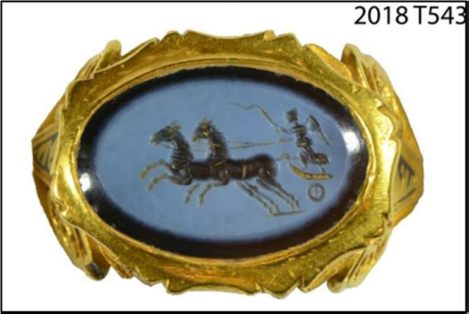
Ilminster Ring

The Trust acquired printed papers relating to the life and works of Sarah Biffin (1784-
1850), a miniaturist painter born in East Quantoxhead without arms or legs. The
collection comprises printed newspaper cuttings, notices, exhibition advertisements
and an obituary and includes 16 documents in total.

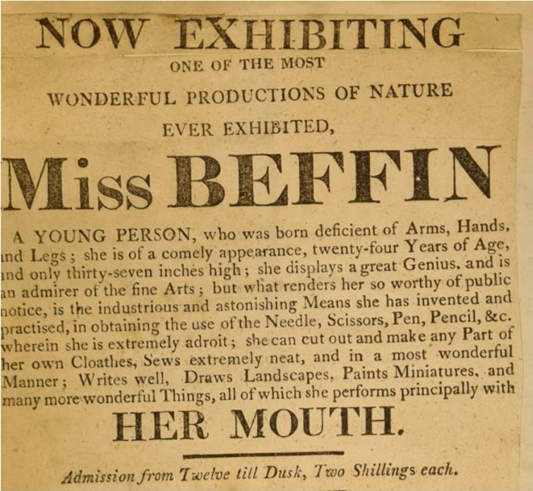
A recently acquired handbill from the Sarah Biffin collection

The Trust has also continued its project to acquire a further collection of artworks and
ephemera relating to the artist Sarah Biffin, which has been valued at £78,250. This new
collection includes significant artworks and personal ephemera that will help us tell
Biffin’s story more fully and complements the existing collection in the care of the Trust.
Successful funding applications were submitted to both the Art Fund and Arts Council England / V&A Purchase Grant fund for £20,000. A further funding application has been submitted to the Friends of the Nations’ Libraries.

Wilfred ‘Wilf’ Peddle’s iconic Morris Minor egg van was generously given to the Somerset Council museum collection. Wilf Peddle, who passed away in June 2024 aged 74, was a true local legend. Born and raised in Glastonbury, he spent his entire life in the town, delivering farm‑fresh eggs from his own hens to residents, cafés and businesses. Wilf’s 1964 Morris Minor, which he had owned since 1972, became inseparable from his identity. The vehicle, which became a familiar sight on the town’s streets for decades, went on display at Somerset Rural Life Museum in Glastonbury during the Easter school holidays.

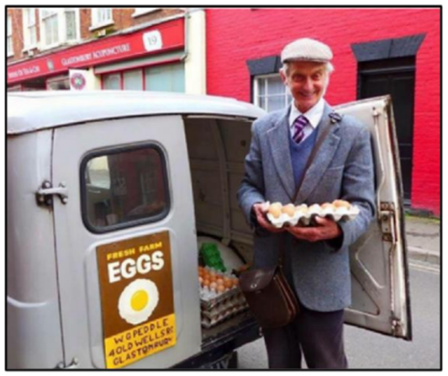
Mr Wilfred Peddle and his Morris Minor
delivery van in Glastonbury

11.11. Loans

The Roman Museum and reconstructed Roman Villa at Hadspen (The Newt in Somerset), which opened to the public on 6 June 2022, continues to attract visitors. The Roman Museum includes the display of items on loan from the Somerset museum collections, including the SANHS collection. Staff visited in March 2026 to check the condition of the loan objects. All the SANHS objects are in good condition.

11.12. Natural Sciences Collections Review

David Gunsthorpe (Chief Executive Officer of Collections Trust) has completed a collections review and significance assessment of the Natural Sciences collections in the care of the South West Heritage Trust. David compiled a report summarising his findings. This identifies a series of recommended actions for managing and caring for the Natural Sciences collections.

11.13 South Somerset Heritage Collection

The Trust has continued to support the management of the South Somerset Heritage Collection. A new Engagement Officer role was created to support programming and the use of the collection. The collection is currently looked after in a purpose-built storage facility on the outskirts of Yeovil by 1.6 members of staff and a small volunteer team.

Due to health and safety concerns identified in December 2025, and relating to the building, which is owned by Somerset Council, Yeovil Town Council has had to close the facility to the public. In order for the required work to take place to address health and safety issues the collections will have to be moved off-site. The timing of the move and the work is yet to be decided. Staff and volunteers are still able to access the site to care for the collections.

Yeovil Town Council are fully committed to ensuring the collection’s long-term future and to making it accessible to the public. A working party has been established that will commission an options appraisal and feasibility study to explore the possibility of the development of a museum or heritage facility in Yeovil. This will include public consultation opportunities for residents, businesses and organisations.

The staff and volunteer team at SSHC are now undertaking a collections audit in preparation for a relocation. This process includes a review of documentation policies and procedures. This work is strengthening understanding of the collections and improving standards of collections management.

Yeovil Town Council remain committed to supporting engagement and outreach work to support access and enjoyment of the collection. A programme of talks, guided walks and off-site exhibitions and events are planned for 2026-7.

The Accreditation team have been informed and are reviewing the situation using their significant change process. It is possible that the Accreditation award will be changed from Full to Provisional to reflect that the South Somerset Heritage Collection is Accredited but not currently open to the public.

South West Heritage Trust are supporting Yeovil Town Council with commissioning the options appraisal and feasibility study.

12. Review of the Museum Forward Collections Management Plan 2025-6 and the Forward Collections Management Plan for 2026-7.

These are provided as a separate document.

Estelle Gilbert
Head of Museums and Engagement
South West Heritage Trust
on behalf of Somerset Council
June 2026

